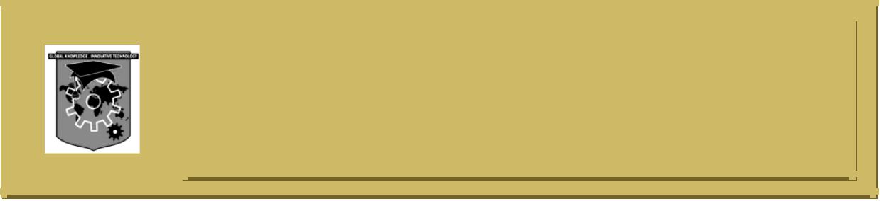**ACS COLLEGE OF ENGINEERINGC:\Documents and Settings\Administrator\Desktop\update kk\New Folder\naac-a-new.png**

**#207, Kambipura, Mysore road, Banglore-74**

**Department of Computer Science & Engineering**

**MODULE -4**

**VIRTUAL MEMORY MANAGEMENT**

1. What is a page fault? With a supporting diagram explain the steps involved in handling page fault.
2. Consider the page reference string for a memory with three frames, how many page faults will occur for FIFO, LRU and optimal page replacement algorithms. Which is most efficient? Reference String: 7, 0, 1, 2, 0, 3, 0, 4, 2, 3, 0, 3, 2, 1, 2, 0, 1, 7, 0, 1
3. For the following page reference calculate the page faults that occur using FIFO and LRU for 3 & 4 page frames respectively. Reference String: 5, 4, 3, 2, 1, 4, 3, 5, 4, 3, 2, 1, 5
4. Consider the following page reference string: 1, 2, 3, 4, 2, 1, 5, 6, 2, 1, 2, 3, 7, 6, 3, 2, 1, 2, 3, 6. How many page faults would occur for the following page replacement algorithms assuming 3 and 5 frames. i) LRU ii) Optimal.
5. Explain copy-on-write process in virtual memory.
6. What is the cause of Thrashing? How does the system detect thrashing?
7. What are the different allocation methods in disk? Explain in detail all the methods.
8. What are the different techniques with which a file can be shared among users?
9. Explain the various storage mechanisms available to store files, with neat diagram.
10. What is a file? List and explain file attributes and file operations.
11. Explain the various access method of files.
12. What are directories? List different types of directory structures with examples. Mention their advantages and disadvantages.
13. What do you mean by free space list? With suitable example, explain any two methods of implementation of free space list.
14. Briefly explain the methods of keeping track of free space on disks.



**ACS COLLEGE OF ENGINEERINGC:\Documents and Settings\Administrator\Desktop\update kk\New Folder\naac-a-new.png**

**#207, Kambipura, Mysore road, Banglore-74**

**Department of Computer Science & Engineering**

**MODULE -5**

**SECONDARY STORAGE STRUCTURES, PROTECTION**

1. What is disk scheduling? List and explain different disk scheduling techniques with example.
2. Given the following queue 95, 180, 34, 119, 11, 123, 62, 64 with head initially at track 50 and ending at track 199. Calculate the number of moves using FCFS, SSTF, Elevator and C-Look algorithm.
3. Suppose that a disk has 50 cylinders named 0 to 49. The R/W head is currently serving at cylinder 15. The queue of pending requests are in order: 4, 40, 11, 35, 7, 14 starting from the current head position. What is the total distance travelled ( in cylinders) by the disk arm to satisfy the requests using algorithms FCFS, SSTF and LOOK. Illustrate with figure in each case.
4. Let a disk drive has 5000 cylinders from 0 to 4999. Currently drive is at 143rd cylinder, and the previous request was at cylinder 125. Queue of pending request in FIFO order is 86, 1470, 913, 1774, 948, 1509, 1022, 1750, 130. What is the total distance the disk arm moves to satisfy all the pending requests for each of the following disk scheduling algorithms from current position i) FCFS ii) SCAN iii) LOOK.
5. What is an access matrix? Explain the different methods of implementing access matrix.
6. Illustrate a model of protection that can be viewed abstracted as matrix. Consider an access matrix contains 4 domain and 4 objects.
7. Explain bad-block recovery in disk.
8. Explain the capability lists methods of implementing access matrix.
9. Differentiate between protection and security.
10. What is protection? Distinguish between mechanism and policies. Explain briefly Access matrix with domains as objects.
11. Write a note on:
12. Domain of protection
13. Access matrix
14. Explain the design principle of Linux.
15. With diagram, explain components of Linux system.
16. Explain in detail, the components that the kernel module support under Linux.
17. Explain the process management in Linux platform.
18. Explain file system implementation in linux.
19. Explain process scheduling and kernel synchronization in detail.
20. Explain the inter process communication mechanisms in Linux.
21. How does Linux manage authentication and access control mechanisms.